**3D-Slicer Dual Modality Registration Plugin Installation Tutorial**

1. Download and install 3D-Slicer (https://download.slicer.org/).
2. Open the bin folder under the installation path of 3D-Slicer on the computer, right-click on this interface and select **Open in Terminal**.
3. Enter the following command in the terminal and press Enter to execute it

**./PythonSlicer.exe -m pip install niftyreg nibabel numpy scipy**

1. Download the DualModalityRegistration.zip file and unzip it to a folder of your choice.

Open 3D-Slicer, click **Edit** in the upper left corner, select **Application Setting**, and add the decompressed modules and plug-ins in the following order. Note that the module and plug-in have the same name, so when you click Add, you should select the subfolder DualModalityRegistration with the same name in the DualModalityRegistration folder under the decompression path. After adding, confirm and restart 3D Slicer as prompted.

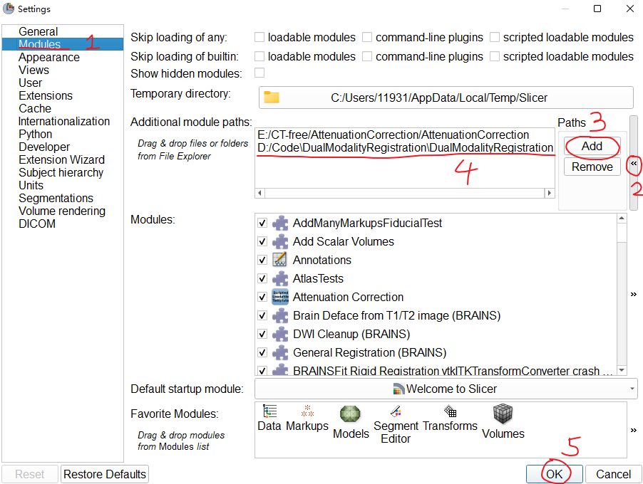

1. Check whether the plug-in is added successfully. The following two pictures are displayed to indicate that the plug-in is added successfully.

